Traveler, Trendsetter or Audiophile?
Back to School: Find your perfect headphones

Wedemark, August 26, 2021 – When a new school year starts, daily routines are changing – and so are our listening habits. It’s important to have the right audio gear for your everyday music and podcast needs. But which type of headphoner are you? Here is a little help to find the right headphones for the upcoming semester.

Type 1: Always on the move, always up to date
You're very active and want to stay up to date, listen to podcasts and music with your smartphone, chat and take calls anytime to always stay in touch? Then you need convenient true wireless earphones for everyday use that fit comfortably in your ears and reliably deliver first-class wireless sound.

Headphones: CX True Wireless
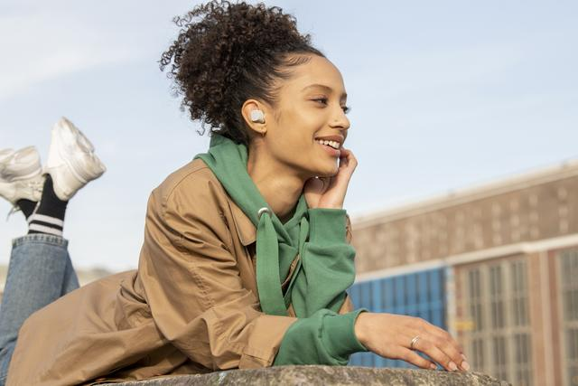
- Best-in-class sound thanks to Sennheiser’s TrueResponse transducer
- customizable touch control
- all-day convenience
- AAC, aptX, SBC codec compatible
- splash water protection according to IPX4
- MSRP: 129 EUR
Type 2: Always one step ahead with tech, style and sound
You’re a pioneer in technological innovations? Your laptop, smartphone and tablet are always up to date, and you value good design? Then premium earphones with the most advanced features are the audio companion of your choice – so you never miss out on the best possible sound in any situation.

Headphones: MOMENTUM True Wireless 2
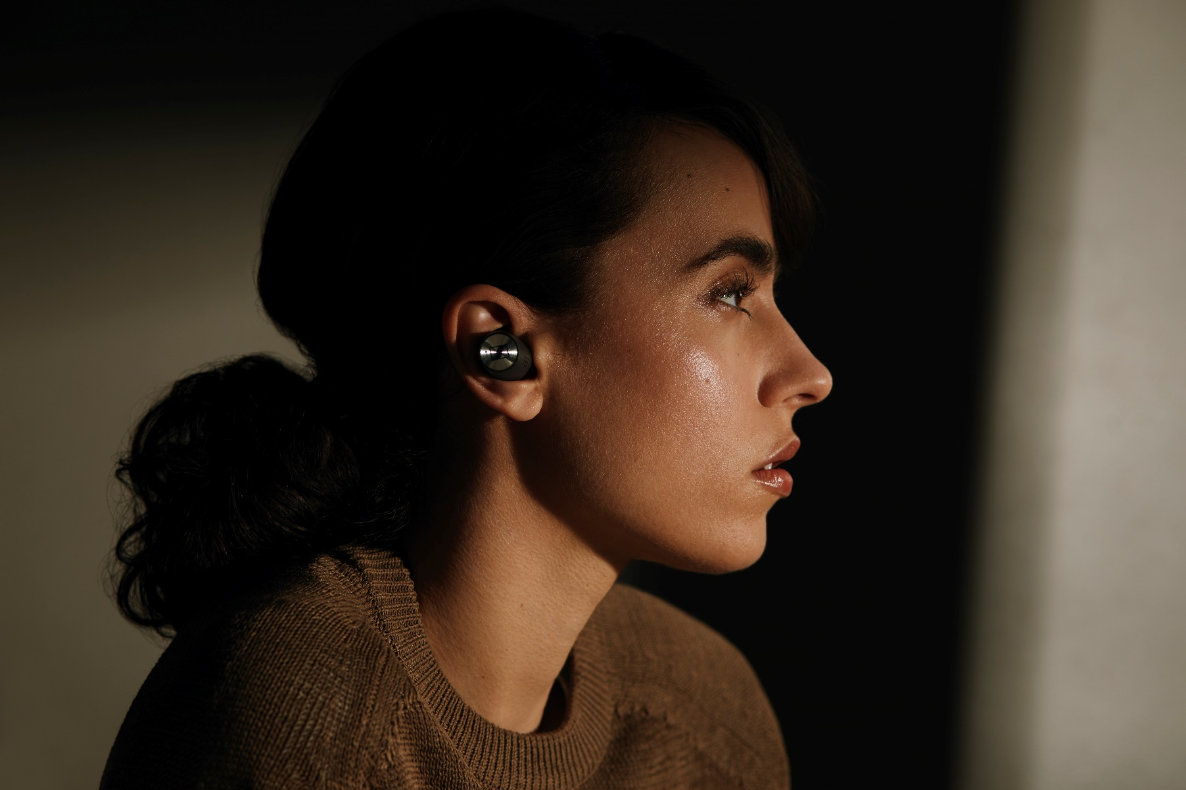
- Best-in-class sound thanks to Sennheiser’s TrueResponse transducer
- Active Noise Cancellation
- Transparent Hearing feature
- automatic Smart Pause feature when taking earbuds out
- 7 hours of playback time, and up to 28 hours by charging on-the go with the supplied case
- MSRP: 299 EUR

Type 3: Travel far, but always stay with yourself
Do you like to immerse yourself in audio books on long journeys during semester breaks? Do you want the best possible sound for your music on the road or sometimes simply to relax and enjoy the peace and quiet? Then a pair of travel headphones with outstanding sound, good wearing and transport comfort as well as optimal noise cancelling will suit you.

Headphones: PXC 550-II Wireless
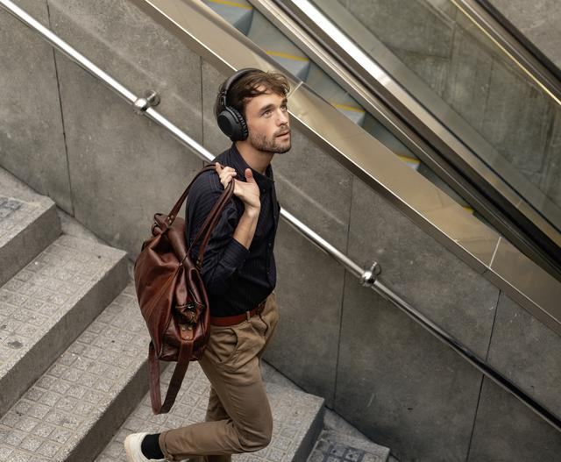
- adaptive ANC with special anti-wind mode
- automatic Smart Pause when taking the headphones off
- optimal comfort thanks to padded headband and rotatable ear cups
- with up to 30 hours of battery life the perfect companion for far away travel destinations
- foldable in transport case
- MSRP: 349 EUR (currently on sale for 199 EUR)

Type 4: The record collection is your sanctuary
For you, music is not consumption, but enjoyment – and sometimes also science? You don't just want to listen to records, you want to analyze and evaluate them so you can hold profound discussions with other connoisseurs? Then you should have a look at audiophile reference headphones that offer precise reproduction across the entire audible frequency spectrum and allow you to experience even the subtlest nuances of sound.

Headphones: HD 560S
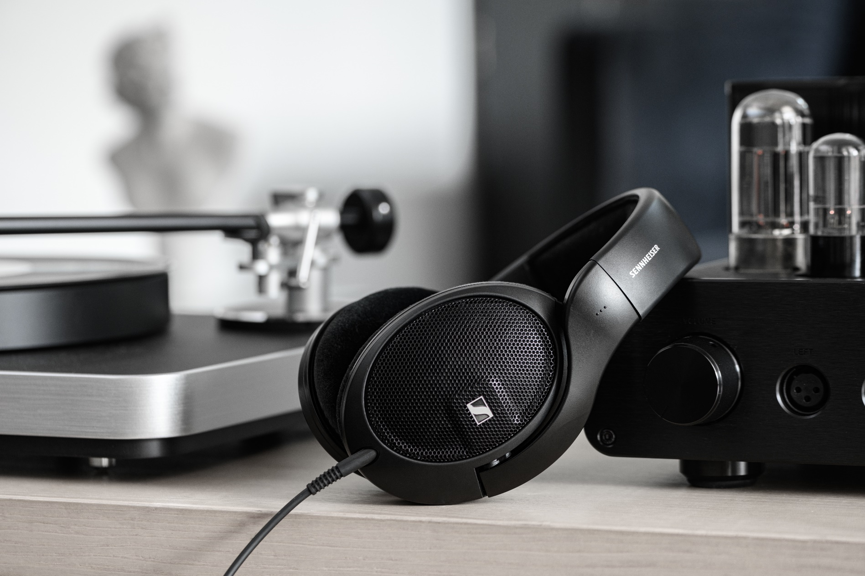
- all-new 120 ohm transducer which effortlessly reproduces deep, defined bass and brilliant treble
- optimal listening position due to angled transducers
- high sensitivity with low harmonic distortion
- ultra-lightweight casing for long listening pleasure
- open-back design with velour ear pads
- MSRP: 199 EUR

Type 5: Everywhere you go, there’s music on your mind
You have a trained ear and real audio competence, maybe even make music yourself – and therefore you want to enjoy the best possible nuanced sound even when on the go? Then a pair of audiophile-grade earphones that offer the highest sound quality should be your everyday companion to let you immerse yourself in music everywhere you go.

Headphones: IE 300 / IE 900
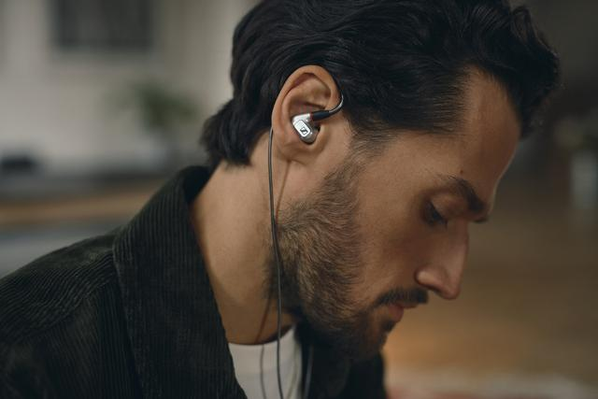
- Wired earphones that create an effortless audiophile listening experience at home and on the go
- clear highs and a transparent midrange reproduction for a particularly low-distortion voice reproduction
- excellent wearing comfort thanks to individually adjustable ear hooks as well as a choice of silicone and memory foam ear adapters
- optimal sound isolation
- MSRP: 299 EUR (IE 300) and 1,299 EUR (IE 900)

ABOUT Sennheiser
Shaping the future of audio and creating unique sound experiences for customers – this aim
unites Sennheiser employees and partners worldwide. The independent family company,
which is managed in the third generation by Dr. Andreas Sennheiser and Daniel Sennheiser, is
today one of the world’s leading manufacturers of headphones, loudspeakers, microphones
and wireless transmission systems. In 2020, the Sennheiser Group generated turnover totaling
€573.5 million. www.sennheiser.com

Global Press Contact
Sennheiser electronic GmbH & Co. KG
Milan Schlegel
PR and Influencer Manager EMEA
T +49 (0)5130 600-1139
milan.schlegel@sennheiser.com

